Lovely Arrangements in Petal Pink
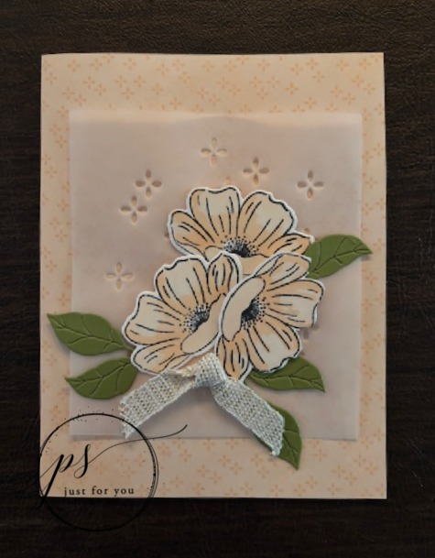
All images © 1999-2026 Stampin’ Up! ®

Supplies:
- Stamp Sets – Lovely Arrangements Bundle (167176)
- Paper – Lovely Blossoms 12”x12” Designer Series Paper; Basic White (166780); Old Olive (100702); Vellum 12”x12” Specialty Paper (167099)
- Stamp Pad – Tuxedo Black Memento Pad (132708)
- Misc. – Stampin’ Cut & Emboss Machine (149653); Multipurpose Liquid Glue (110755); Fine Art Ribbon (154561); Petal Pink Stampin’ Blends Combo Pack (154893); Paper Trimmer (152392); Dimensionals (104430); Mini Glue Dots (144108); Wink of Stella Brush (141897)

Measurements:
- Lovely blossoms DSP: 8 ½” x 5 ½”, scored at 4 ¼”
- Basic White: 2” x 6”
- Old Olive 2” x 5”
- Vellum: 3 1/2” x 4”
- Ribbon: 5”

Instructions:
- Fold DSP to create the base card. Die cut vellum and adhere with Glue in area that will be covered by the flowers.
- Stamp flowers, color with the blends and die cut. Die cut the leaves.
- Arrange leaves and flowers on top of the vellum similar to the card pictured. Adhere the leaves first. Adhere two of the flowers using the Glue. Adhere the third flower with a Dimensional.
- Tie the ribbon in a simple knot and adhere with a Mini Glue Dot, trim ends.
- Brush the flowers gently with the Wink of Stella.

